**If it matters to you then it matters to us**

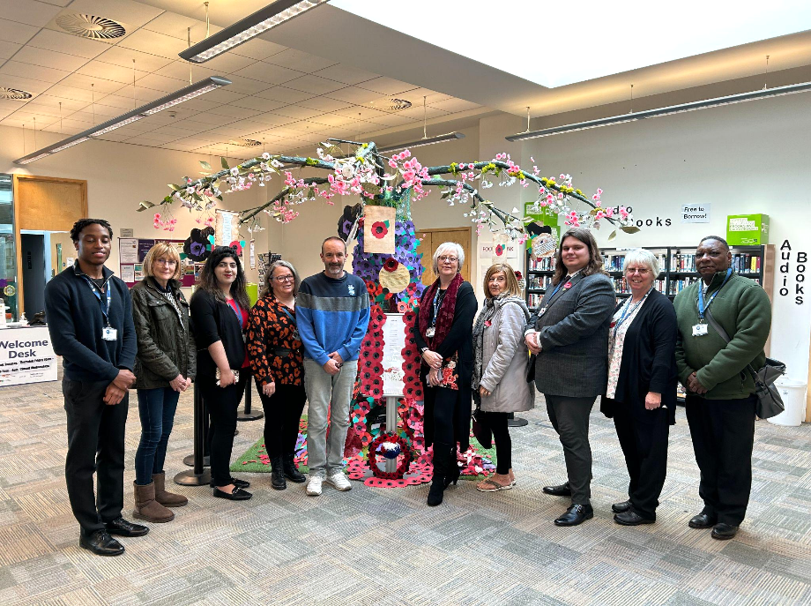

Your health is a treasure, and caring for it involves more than just relying on medicine. At Citizens Advice Solihull Borough, we understand that your wellbeing is influenced by a multitude of factors. Our Social Prescribing team is at your service, ready to support you in making positive changes that will leave you feeling your absolute best. We believe that health is not just about physical well-being but also mental and emotional wellness. With our help, you can explore the possibilities to improve your overall quality of life.

Citizens Advice Solihull Borough is proud to provide the social prescribing service on behalf of the Rural Primary Care Network which is made of Arden Medical Centre, Dorridge, Hampton in Arden, Balsall Common and Meriden GP surgeries. Our services are seamlessly integrated into these medical practices, working in harmony with your trusted GPs and other healthcare professionals to bring you a holistic approach to healthcare.

We offer you a safe and confidential space to open up and discuss the aspects of your life that may be impacting your health negatively. We're here to listen to "What Matters to You." Our support is practical, compassionate, and judgment-free, and we aim to provide you with guidance, advice, and advocacy that will make a real difference.

But that's not all we do. We link you to a wide array of services, local support networks, and community groups. Our goal is to foster social connections, improve your confidence and enhance your independence.

Getting started is easy! Simply reach out to your GP surgery and ask for a referral to our service. You can also take the initiative and complete our online self-referral form on our website at https://www.casbe.org.uk

If you prefer a more personal touch, join us for one of our coffee and chat sessions at Balsall Common Library between 11 am and 1 pm on the following dates: February 14th and 28th, March 13th and 27th, April 10th and 24th and fortnightly after that.

We are excited to meet you, to listen to your story, and to help you achieve a brighter, healthier tomorrow.

